**Leela Prasad Yadav Vullipayala**

Linux Admin | DevOps Engineer | IT Infrastructure Admin

Phone: +919513031322 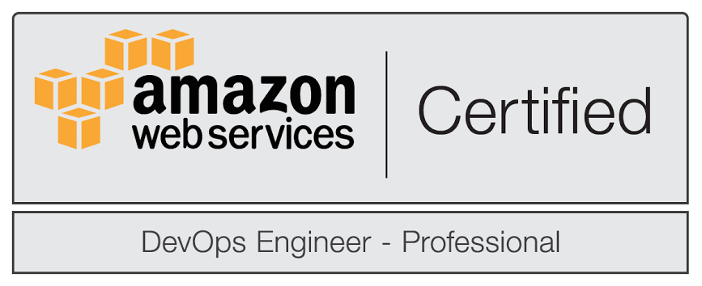

Email: prasadkarthikeyan18@gmail.com

# Objective

Systematic and technical expertise in setting up and managing IT infrastructure as a DevOps Engineering, LINUX & UNIX Administration

# Education

Done Spl.Diploma in Computer Science – Government Institute of Technology College – Secunderabad. 2006 July – 2009 December.

Done Bachelor’s in Computer Science – Siddhartha Institute of Engineering and Technology College – Puttur (A.P). 2010 – 2013 April.

# CERTIFICATIONS:

DevOps Engineer Certified – Certificate DevOps ID : FSLNNABJ

# SOFTWARE SKILLS:

|  |  |
| --- | --- |
| Operating Systems: | AmazonAMI,Linux(Ubuntu,Centos,RedHat), Windows. |
| Cloud Infrastructure: | AWS(EC2,VPC,ELB,Auto-Scaling,RDS) |
| Version Control Tools | GIT, GitHub, ClearCase Tool. |
| CI/CD Tools | Jenkins, Maven, Ant. |
| Databases: | MySQL, Maria DB |
| Web/Application Servers: | IBM Web sphere, Nginx, Apache Tomcat, IIS. |
| Containerization Tools | Docker, Docker Swarm |
| Configure Management Tools | Ansible. |

# Experience

## DevOPS Engineer | FOCUS SOFTEK PRIVATE LIMITED

Location: Bangalore, India. Feb - 2015 to June - 2019

Client: GMSDC

Project: Cloud Infrastructure Architect to deploy gaming applications

**Brief description of the project:**

Provide Infrastructure for the web application through AWS Cloud Services. Installing & Configuring Middleware Servers in cloud infrastructure. Create CI/CD pipeline with Jenkins, Docker and automate with Ansible.

**Responsibilities:**

* Hands on experience in build, design, deployment, and ability to maintain the continuous integration and continuous delivery process for SaaS applications using tools like Jenkins, maven Git, etc.
* Ability to automate test and deploy the code and monitor.
* Work in close coordination with the development and operations team such that the application is in line with performance according to the customer's expectation.
* Planned and implemented a complete cloud infrastructure based on the budgetary requirements and future objectives set forth by management.
* Assisted with the implementation of automation and provisioning tools like Ansible/Jenkins for continuous integration of their applications.
* Experience working on Docker hub, creating Docker images and handling multiple images primarily for middleware installations and domain configuration.
* Work closely with Project Managers to understand a code/configuration release scope and how to confirm a release was successful.
* Created and managed a Docker deployment pipeline for custom application images in the cloud using Jenkins.
* Integrated GIT with Jenkins to automate the code checkout process with the help of Jenkins DSL plugin.
* Designed the project pipelines using Jenkins for Continuous Integration and deployment into different Web/Application Servers.
* Managed Kubernetes charts using Helm. Created reproducible builds of the Kubernetes applications, managed Kubernetes manifest files and managed releases of Helm packages.
* Setup the Jenkins jobs for Continuous integration process and to execute test cases
* Configured Gitlab with Jenkins and schedule jobs using POLL SCM option.
* Designed and implemented scalable, secure cloud architecture based on Amazon Web services.
* Deployed application packages on to Apache Tomcat Server. Coordinated with software development team and QA Teams on issues and solved the problems.
* Managed Maven project dependencies by creating parent-child relationship between projects.
* Responsible for a plugin management, User management, Build/Deploy pipeline setup and end-end job setup of all the projects.
* Created and maintained the shell deployment scripts for WebLogic and web application servers.
* Worked on confluence to share knowledge with other teams performed integrating, JUnit and code quality Tests as a part of Build Process.
* Performed regular builds deployment of the packages of testing in different environments (DEV,QA, CERT, UAT and PROD)

Environment: AWS EC2, Jenkins, Middleware Servers, Database Servers, Maven repo, Git, GitHub, Docker Registry, Ansible, Docker Containers.

## DevOPS Engineer | IBM Private LTD (Under Payroll of Quess CORP)

Location: Bangalore, India. June - 2019 to June -2020

Client: VISTA

Project: Agile Process

**Brief description of the project:**

Providing end to end delivery and deployments to swiss pension scheme banking services application. Regular builds with generated sonar reports and WAS deployments in production environment.

**Responsibilities:**

* Having good experience in creating automation pipelines in Jenkins administration
* Having good experience in maven build automation and responsible for error and troubleshooting builds.
* Interfaced with developers for application projects
* Provided extensive support in code deploy, change management, and application level troubleshooting for the Dev, Test, Pre-Prod & Production environment
* Installed, configured & upgraded WAS for all Dev, Test, Pre-Prod & Production environments.
* Worked closely with development, messaging, network support teams, as the application was integrated with other products.
* Involved in testing of the web URLs and software installed and versions migrated.
* Involved extensively in trouble shooting the issues and finding out root cause analysis.
* Worked closely with vendors during trouble tickets and in coming to a solution.
* Worked with the team for writing and deploying shell scripts to automate various tasks like start and stop scripts, log rotation.
* Responsible for the Error and troubleshooting for the users of WAS 5.0 and WBI. Deployed hundreds of J2EE applications, and the backend were DB2 using Stored Procedures, which were developed using WSAD.
* Having good experience in Sonarqube & Artifactory Administration.
* Having knowledge on Kubernetes

Environment: IBM Cloud Servers, Jenkins, IBM WebSphere, ClearCase , Shell Scripting, Sonarqube Administration, Maven JFrog Artifactory Administration, PowerShell Scripting, Kubernetes

## IT Infrastructure ADMIN | Technoidentity PRIVAte LTD

Location: Hyderabad, India. June - 2020 to till-date

Client: Deposit-Solutions

Project: Deutsche Bank, Frankfurt

**Brief description of the project:**

Providing organisations access to shared pools of data, services and resources

avoid expending time, effort and money on infrastructure and IT maintenance

build a safe and secure platform to host data

**Responsibilities:**

* Approve change requests related to modifications to cloud resource
* View pending endorsements for cloud resources
* View and examine summary data on cloud resource deployments
* Monitor demands and key metrics for cloud resources
* Having extraordinary knowledge of Code Green, Proofpoint, Active Directory, Exchange, Office 365, Azure, AWS, GCP, and various Windows-based innovations
* capacity to configure VMs and Web Applications is an added advantage to become a cloud system administrator
* Improving security configurations, fixing, and troubleshooting. The staff additionally maintains system security strategies, policies, and procedures
* Providing Secure data to the cloud Instances

Environment: AWS EC2 Instance, Amazon Cloud Watch, Amazon EC2 Autoscaling, AWS Serverless Application Repository, Amazon RDS